**Unveiling The Virtual Classroom: An In-Depth Analysis of The Online Education System**

**PROJECT REPORT**

|  |  |
| --- | --- |
| **Name** | **Dr. A. SHOBANADEVI** |
| **Project Name** | **An In-Depth Analysis of The Online Education System** |

1. **INTRODUCTION** 
   1. Project Overview
   2. Purpose
2. **LITERATURE SURVEY**
   1. Existing problem
   2. Proposed solution
3. **THEORITICAL ANALYSIS**
   1. Block Diagram
   2. Hardware / Software requirements
4. **EXPERIMENTAL INVESTIGATIONS**
5. **FLOWCHART**
6. **RESULTS**
7. **ADVANTAGES & DISADVANTAGES**
8. **APPLICATIONS**
9. **CONCLUSION**
10. **FUTURE SCOPE**
11. **BIBLIOGRAPHY**
12. **APPENDIX**

**1. INTRODUCTION**

* 1. **Overview**

The "Unveiling the Virtual Classroom" project is an in-depth analysis of the online education system, focusing on virtual classrooms and their impact on modern education. This project aims to explore the various aspects of online education, including its benefits, challenges, technological infrastructure, pedagogical strategies, and the overall learning experience. The project also aims to provide insights into the effectiveness of virtual classrooms in comparison to traditional classroom settings.

* 1. **Purpose The use of this project.**

**Project Objectives:**

**Investigate Online Education Landscape:** Research and understand the current state of online education, its growth trajectory, and its relevance in today's world.

**Explore Virtual Classroom Platforms:** Evaluate and compare different virtual classroom platforms, including their features, user-friendliness, and adaptability to various educational settings.

**Analyze Pedagogical Strategies:** Investigate the pedagogical approaches used in virtual classrooms, including methods for engaging students, promoting active learning, and assessing student performance.

**Examine Technological Infrastructure:** Understand the technological requirements for seamless virtual classroom experiences, including internet bandwidth, device compatibility, and audio/video tools.

**Evaluate Learning Outcomes:** Assess the effectiveness of online education by comparing learning outcomes, retention rates, and student satisfaction in virtual classrooms versus traditional classrooms.

**Identify Benefits and Challenges:** Identify the advantages and challenges of online education from the perspectives of students, educators, and institutions.

**Recommend Best Practices:** Based on the analysis, provide recommendations for optimizing virtual classroom experiences and improving the overall quality of online education.

**2. LITERATURE SURVEY**

**2.1 Existing problem**

In the context of the project "Unveiling The Virtual Classroom: An In-Depth Analysis of The Online Education System," the literature survey reveals a plethora of existing approaches and methods that have been proposed to address various aspects of online education and virtual classrooms. These approaches encompass technological, pedagogical, and practical solutions aimed at enhancing the effectiveness of online education. Here are some key existing approaches identified in the literature:

1. Lack of security since large data processed simultaneously

2. Hybrid Technique can fail if nonlinear model fails to capture residue patterns

3. The experiment only considers the features of the product and does not consider external influences, such as the impact of regulations on sales. It uses only small dataset.

4. Dataset is limited

5. The experiment only considers the features of the product and does not consider external influences, such as the impact of regulations on sales. It uses only small dataset.

**Blended Learning Models:**

Blended learning combines traditional face-to-face instruction with online components. This approach seeks to strike a balance between the benefits of in-person interaction and the flexibility of online learning. Blended models integrate synchronous virtual classroom sessions with asynchronous online content, creating a cohesive learning experience.

**Flipped Classroom Strategy:**

The flipped classroom model involves delivering instructional content online before class and using in-person or virtual classroom time for interactive discussions, problem-solving, and collaborative activities. This approach capitalizes on virtual platforms to provide pre-recorded lectures and resources, enabling valuable engagement during live sessions.

**Interactive Assessments and Gamification:**

To maintain student engagement in virtual classrooms, interactive assessments and gamification techniques are employed. These approaches use quizzes, polls, interactive simulations, and educational games to make learning more enjoyable and participatory.

**Synchronous and Asynchronous Interaction:**

The distinction between synchronous and asynchronous interaction is crucial. Synchronous interaction involves real-time communication through virtual classroom sessions, chats, and video conferencing. Asynchronous interaction allows students to engage with course materials and discussions at their own pace, offering flexibility to accommodate different learning styles.

**Peer-to-Peer Collaboration:**

Leveraging virtual platforms, students can collaborate on projects, assignments, and discussions in virtual groups. Peer-to-peer interaction promotes active learning, knowledge sharing, and the development of teamwork skills.

**Adaptive Learning Technologies:**

Adaptive learning technologies use data analytics to tailor educational content to individual learner needs. These platforms analyze student performance and adjust the difficulty and pace of lessons accordingly, optimizing the learning process.

**Augmented and Virtual Reality (AR/VR):**

AR and VR technologies enhance the virtual classroom experience by creating immersive environments for simulations, virtual field trips, and interactive 3D models. These technologies provide unique opportunities for experiential learning.

**Effective Online Assessment Strategies:**

The literature discusses various online assessment methods, including open-book exams, project-based assessments, and continuous evaluation through discussion participation, quizzes, and assignments.

**Teacher Training and Support:**

Effective teacher training programs are emphasized to equip educators with the skills and confidence to manage virtual classrooms. Pedagogical training focuses on adapting teaching methods for online environments and ensuring learner engagement.

**Accessibility and Inclusivity:**

Ensuring that virtual classroom platforms and materials are accessible to all students, including those with disabilities, is a significant concern. The literature suggests various methods to create inclusive online learning environments.

**Data Privacy and Security:**

As virtual classrooms involve online interactions and data sharing, ensuring the privacy and security of student information is crucial. Existing approaches emphasize implementing robust cybersecurity measures and complying with relevant regulations.

**Continuous Improvement and Feedback:**

Ongoing feedback loops and evaluations help educators refine their virtual classroom strategies. Regular surveys, polls, and discussions allow instructors to gauge student satisfaction and adjust their methods accordingly.

The existing literature presents a rich landscape of approaches and methods designed to address the challenges and opportunities presented by virtual classrooms and online education. These approaches encompass a wide range of technological, pedagogical, and administrative solutions, aiming to create engaging, effective, and inclusive virtual learning environments. By considering and adapting these approaches, the project "Unveiling The Virtual Classroom" can gain valuable insights into best practices for analyzing and optimizing the online education system.

**2.2 Proposed solution**

**Idea / Solution description:**

Use the Cognos technology to collect and use online education reviews data to derive actionable insights. It is used to identify, optimize, and forecast about the online education system. It uses revies data to plan an efficient education system model that generates efficient learning platform for the students. Users can create multiple Analytical Visualizations and can build the required Dashboards.

**Novelty / Uniqueness:**

Understanding performance with customer reviews data analytics helps online learning platforms and education management teams to review their strategies and performance in order to make improvements. Review analytics provides valuable information like Customer Analysis and Product Analysis to improve virtual learning methodologies. Users create multiple analytical graphs/charts/Visualizations.

**Social Impact / Customer Satisfaction:**

Analyzing societal reviews helps businesses in understanding their most profitable products and the ones that are not moving, most profitable customers, and potential learning opportunities thereby providing e-platform which match customer needs and meets their satisfaction.

**Business Model (Revenue Model):**

Cognos Education review analytics can use the learners review data and provide actionable insights for selling a virtual learning product or service to a consumer or business.

**Scalability of the Solution:**

This solution can be used from small learning modules to multinational companies. This solution can be processed with less memory and quickly. The solution can be used as user specified so it is easy to customer.

**IBM Cognos Analytics:**

IBM Cognos Analytics tool simply means that you have found a problem with your customer and that the solution you have realized for it actually solves the customer’s problem. It helps to identify behavioral patterns and recognize on learning platform reviews.

**Purpose:**

● Solve complex problems in a way that fits the state of your customers. •

● Succeed faster and increase your solution adoption by tapping into existing mediums and channels of behavior. •

● Sharpen your communication and marketing strategy with the right triggers and messaging. •

● Increase touch-points with your company by finding the right problem-behavior fit and building trust by solving frequent annoyances, or urgent or costly problems. •

● Understand the existing situation in order to improve it for your target group.

**3. THEORITICAL ANALYSIS**

**3.1 Block diagram**

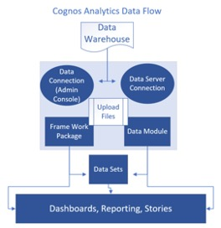

**3.2 Hardware / Software requirements of the project:**

**Software Requirements: IBM Cognos Analytics Tool**

**Functional Requirements:**

|  |  |  |
| --- | --- | --- |
| **FR No.** | **Functional Requirement (Epic)** | **Sub Requirement (Story / Sub-Task)** |
| FR-1 | User Registration | Registration through Website Registration through Gmail |
| FR-2 | User Confirmation | Confirmation via Email |
| FR-3 | User Login | Login via Gmail and Password |
| FR-4 | Generating Report | User can view the product details |

**Non-functional Requirements**

|  |  |  |
| --- | --- | --- |
| **FR No.** | **Non-Functional Requirement** | **Description** |
| NFR-1 | Usability | This service will have a simple and user-friendly graphical interface. Users will be able to understand and use all the features easily. |
| NFR-2 | Security | The main security concern is for users login information is end to end encryption should be used to avoid hacking. |
| NFR-3 | Reliability | It has high reliability because when the system is disconnected or internet connection lost, it should save all the process of the users made. |
| NFR-4 | Performance | A good internet speed while browsing the product it had high performance with efficiency. |
| NFR-5 | Availability | It will be available 24 hours a day and seven days a week. User access anywhere at any time . |
| NFR-6 | Scalability | A Many users can access the website simultaneously. |

**4. EXPERIMENTAL INVESTIGATIONS**

The number of unique visualizations that can be created with a given dataset. Some common types of visualizations that can be used to analyze the online education data include bar charts, line charts, heat maps, scatter plots, pie charts, Maps etc. These visualizations can be used to compare performance, track changes over time, show distribution, and relationships between variables, breakdown of revenue and customer demographics, workload, resource allocation and location of hotels.

* Column Chart: Age(Years) by Your level of satisfaction in Online Education
* Bar Chart: Internet facility in your locality by Your level of satisfaction in Online Education
* Bar chart: Performance in online by Level of Education
* Pie Chart: Time spent on social media (Hours) by Device type used to attend classes
* Packed bubbles : Engaged in group studies? coloured by Engaged in group studies? sized by Performance in online
* Word cloud: Average marks scored before pandemic in traditional classroom
* Table: Economic status, Home Location and Performance in online
* Radial Chart:
* Line Chart: Performance in online by study time(hours)
* Line Chart: Performance in online by sleep time(hours)

**5. FLOWCHART**

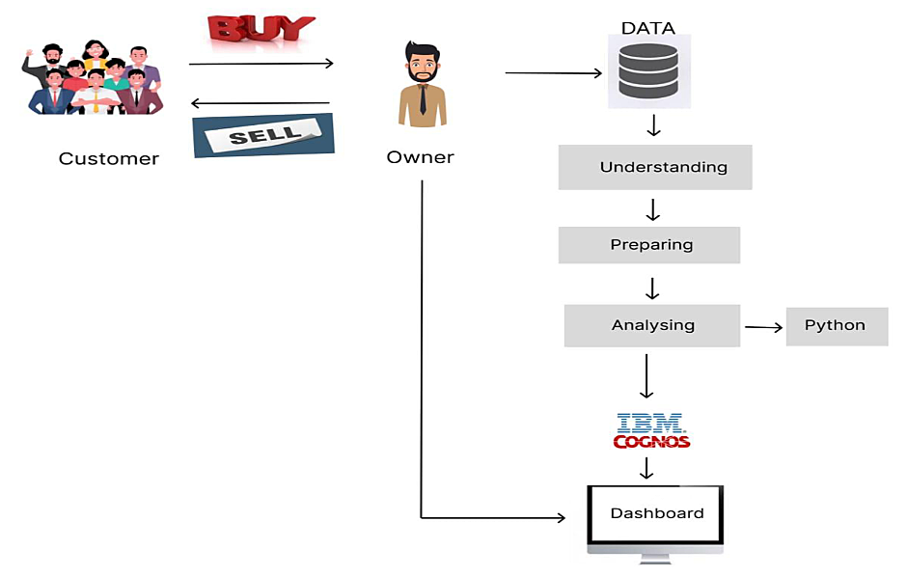

**6. RESULTS**

**Online Education Data Module:**

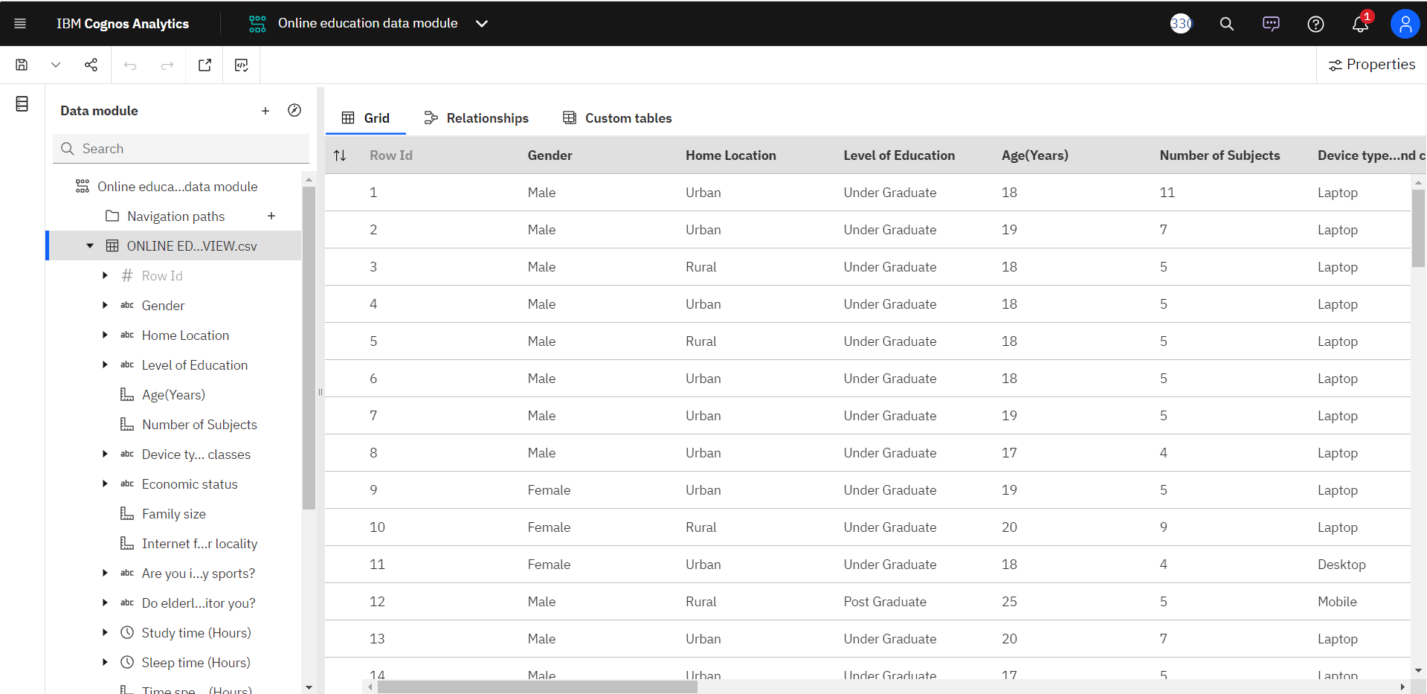

**Online Education Data Exploration:**

1. **Internet facility in your locality by Your level of satisfaction in Online Education:**

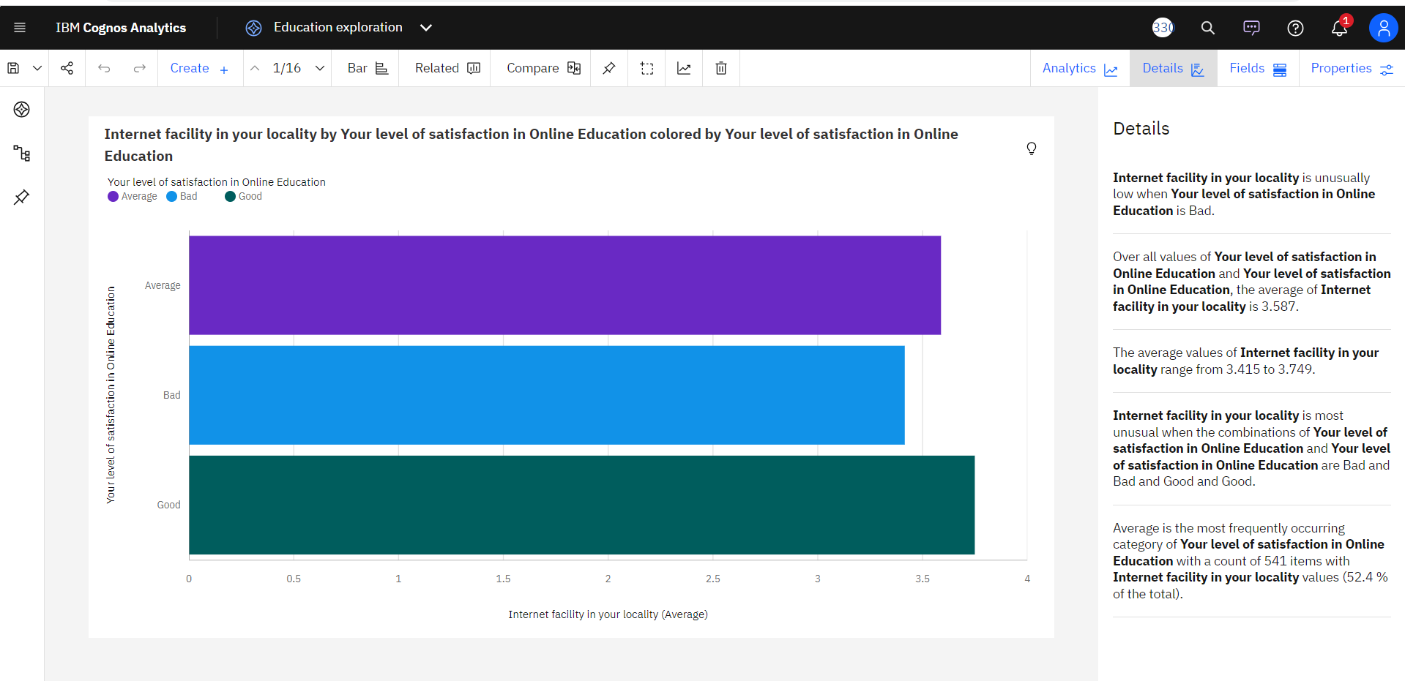

1. **Time spent on social media (Hours) by Device type used to attend classes:**

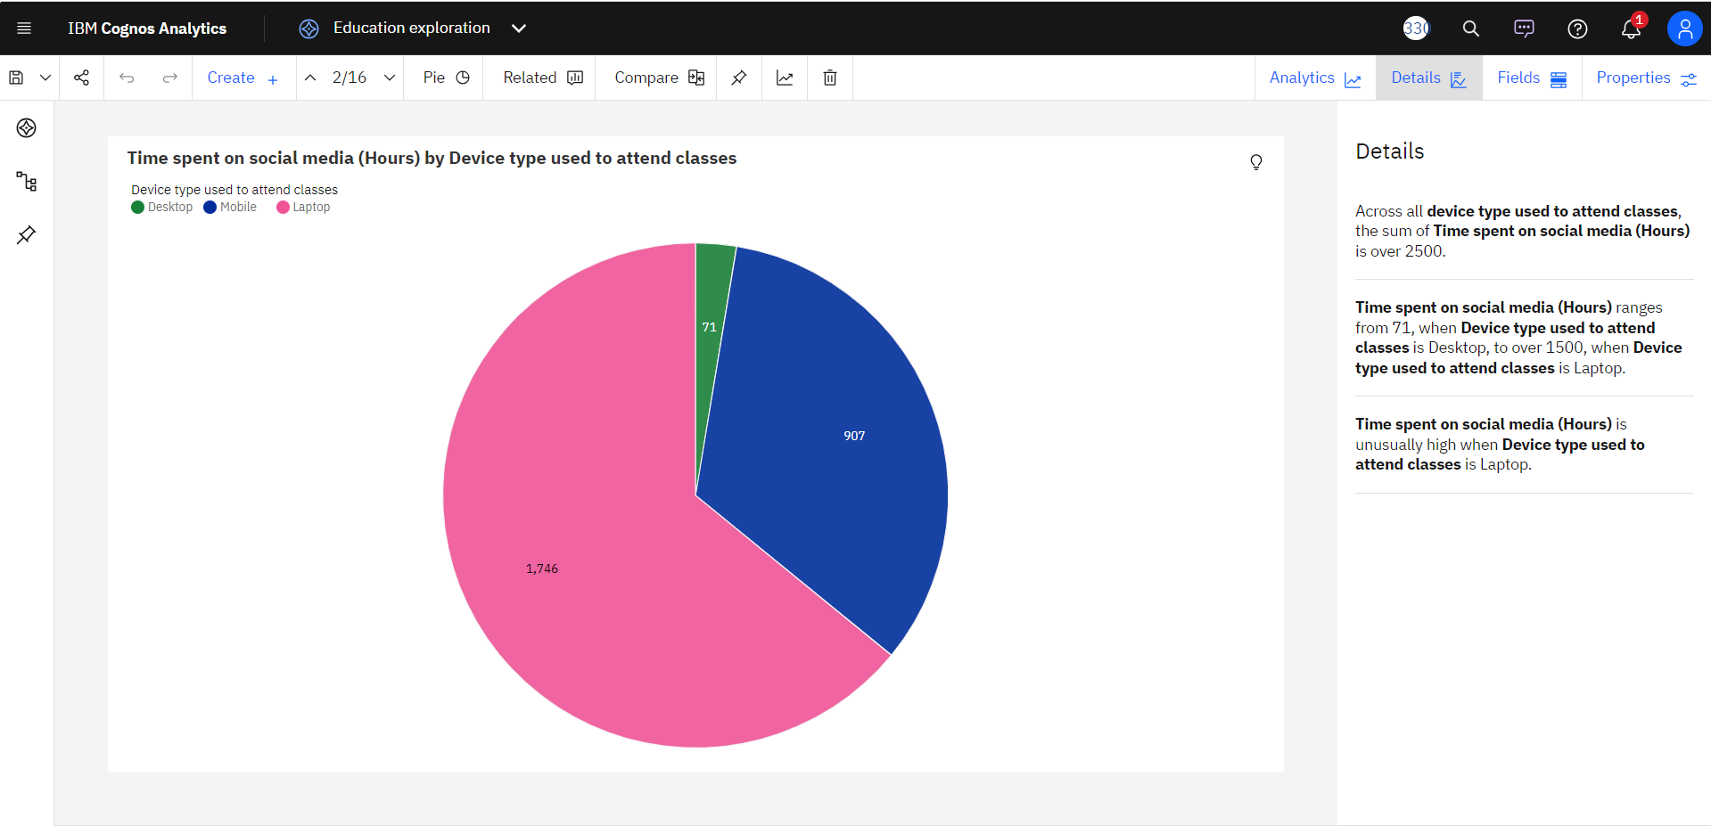

1. **Your level of satisfaction in Online Education:**

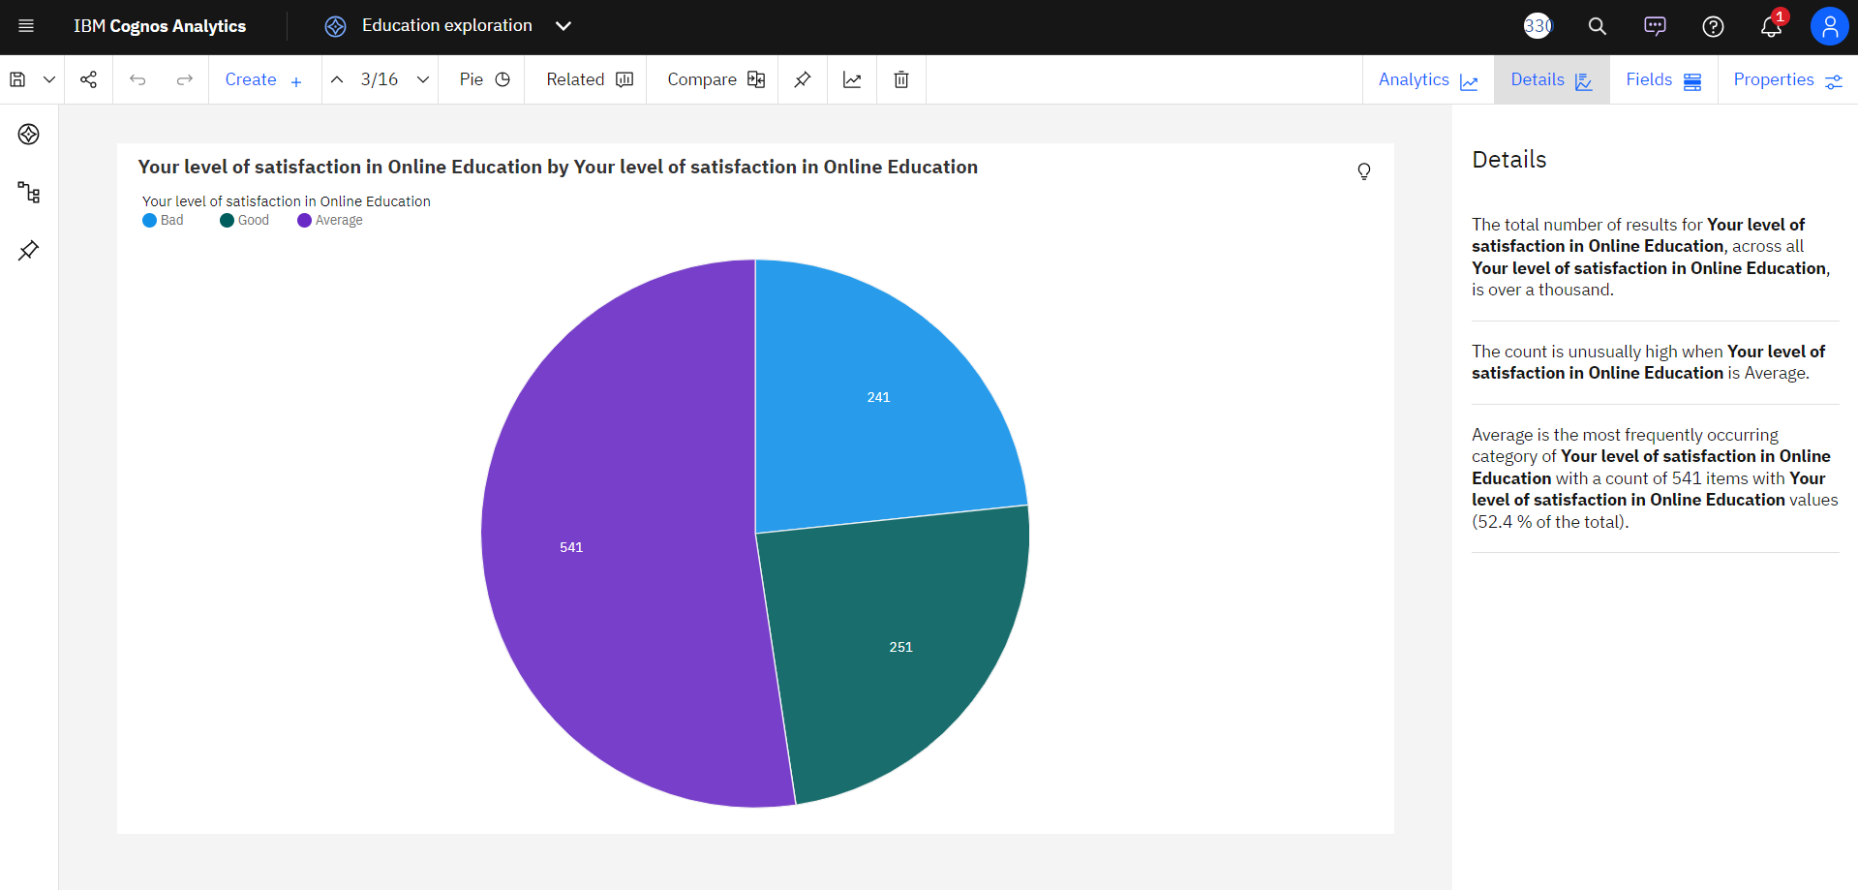

1. **Average marks scored before pandemic in traditional classroom:**

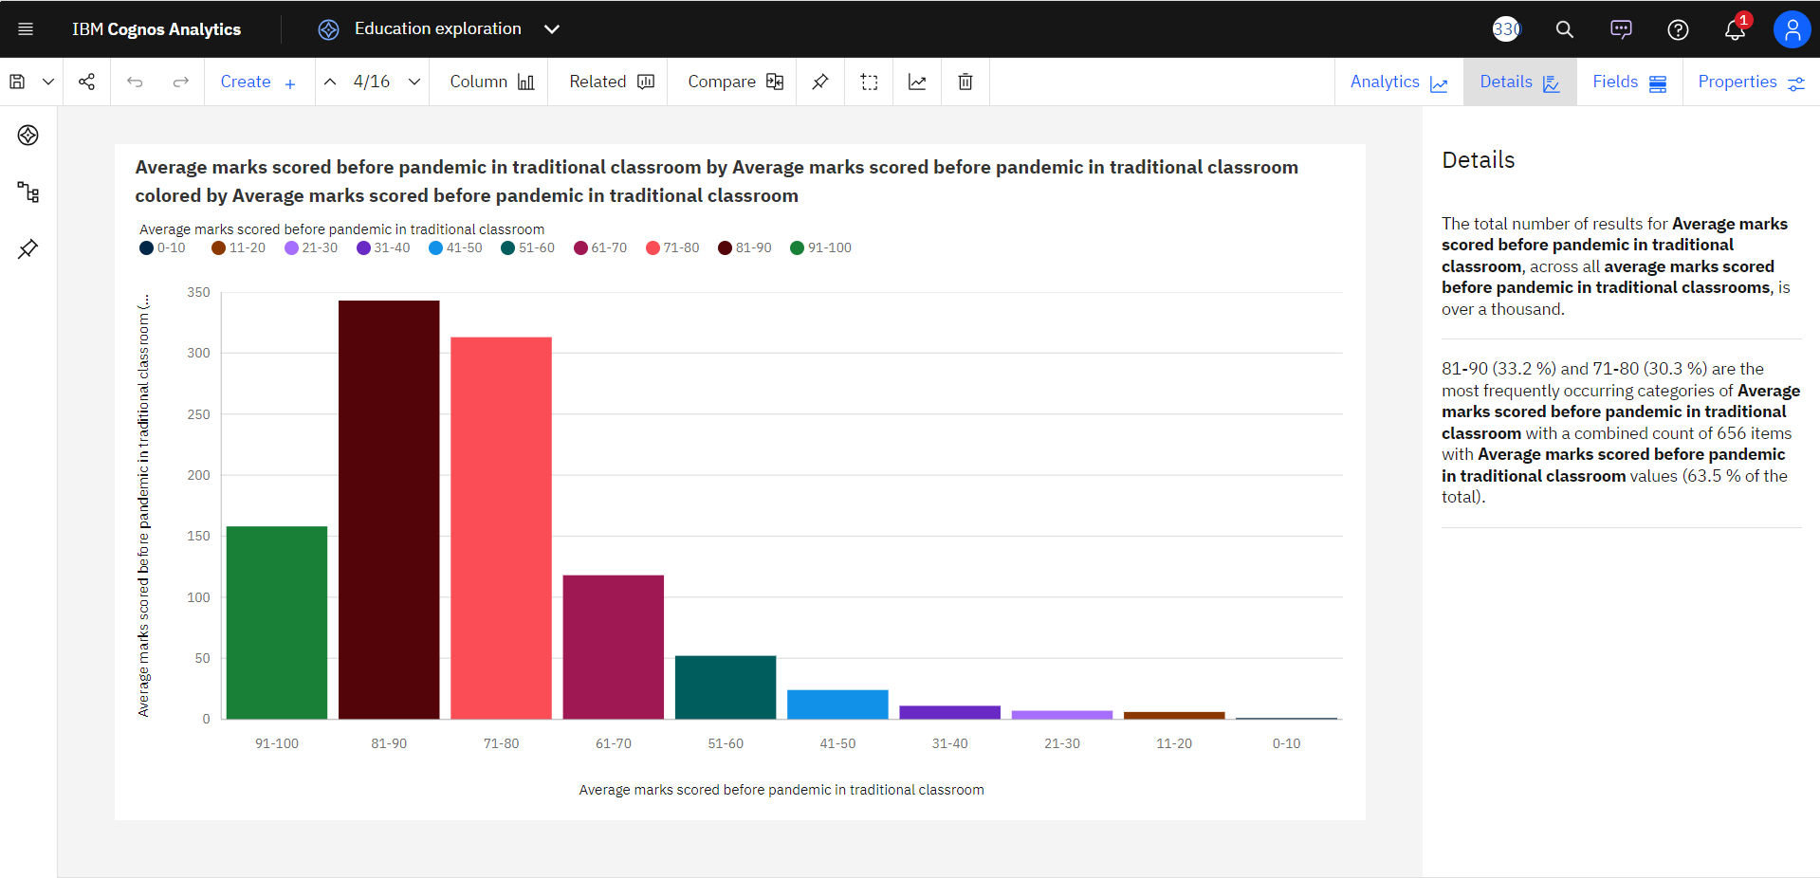

1. **Study time (Hours):**

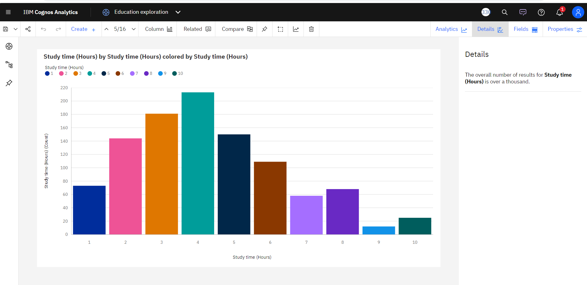

1. **Interested in?:**

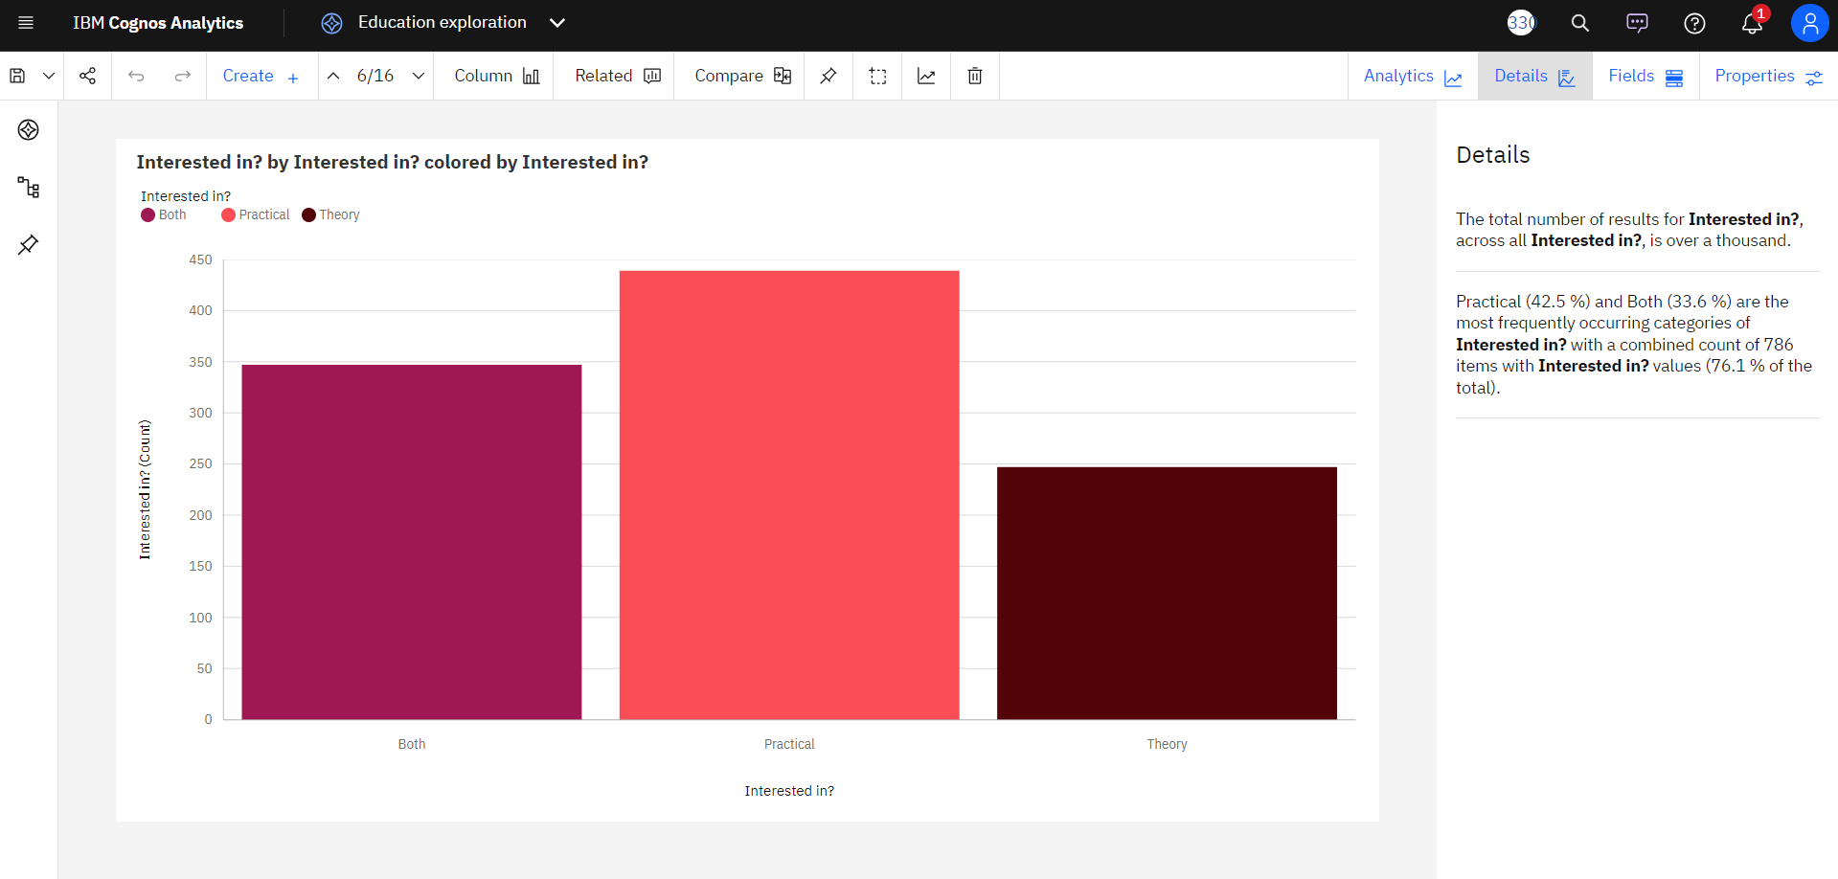

1. **Level of Education:**

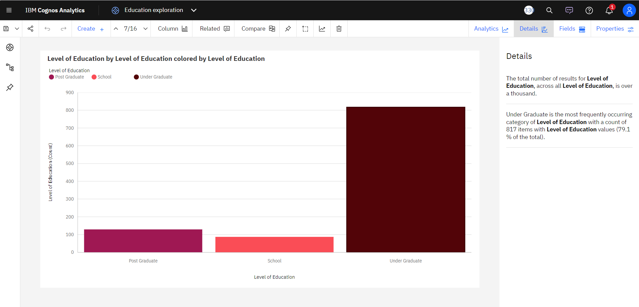

1. **Engaged in group studies?:**

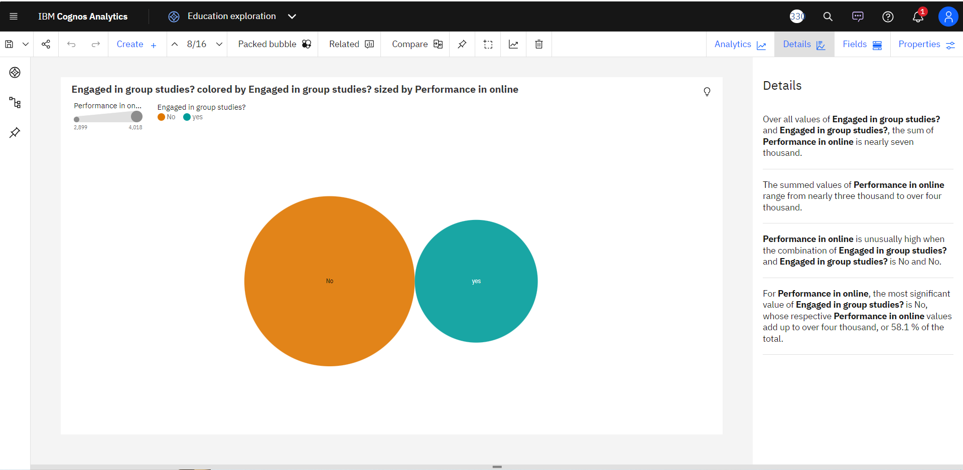

1. **Average marks scored before pandemic in traditional classroom :**

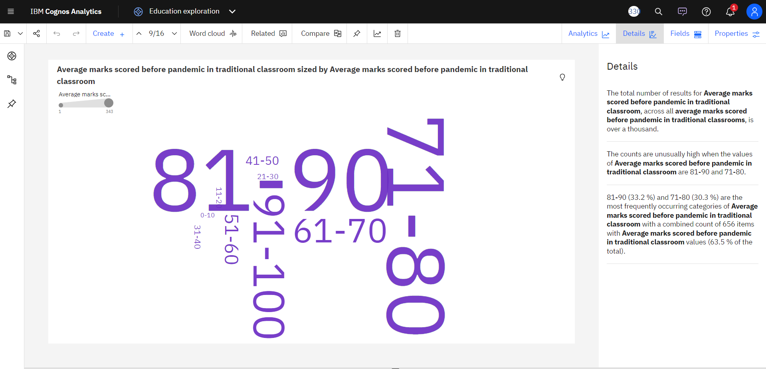

1. **Age(Years) by Your level of satisfaction in Online Education:**

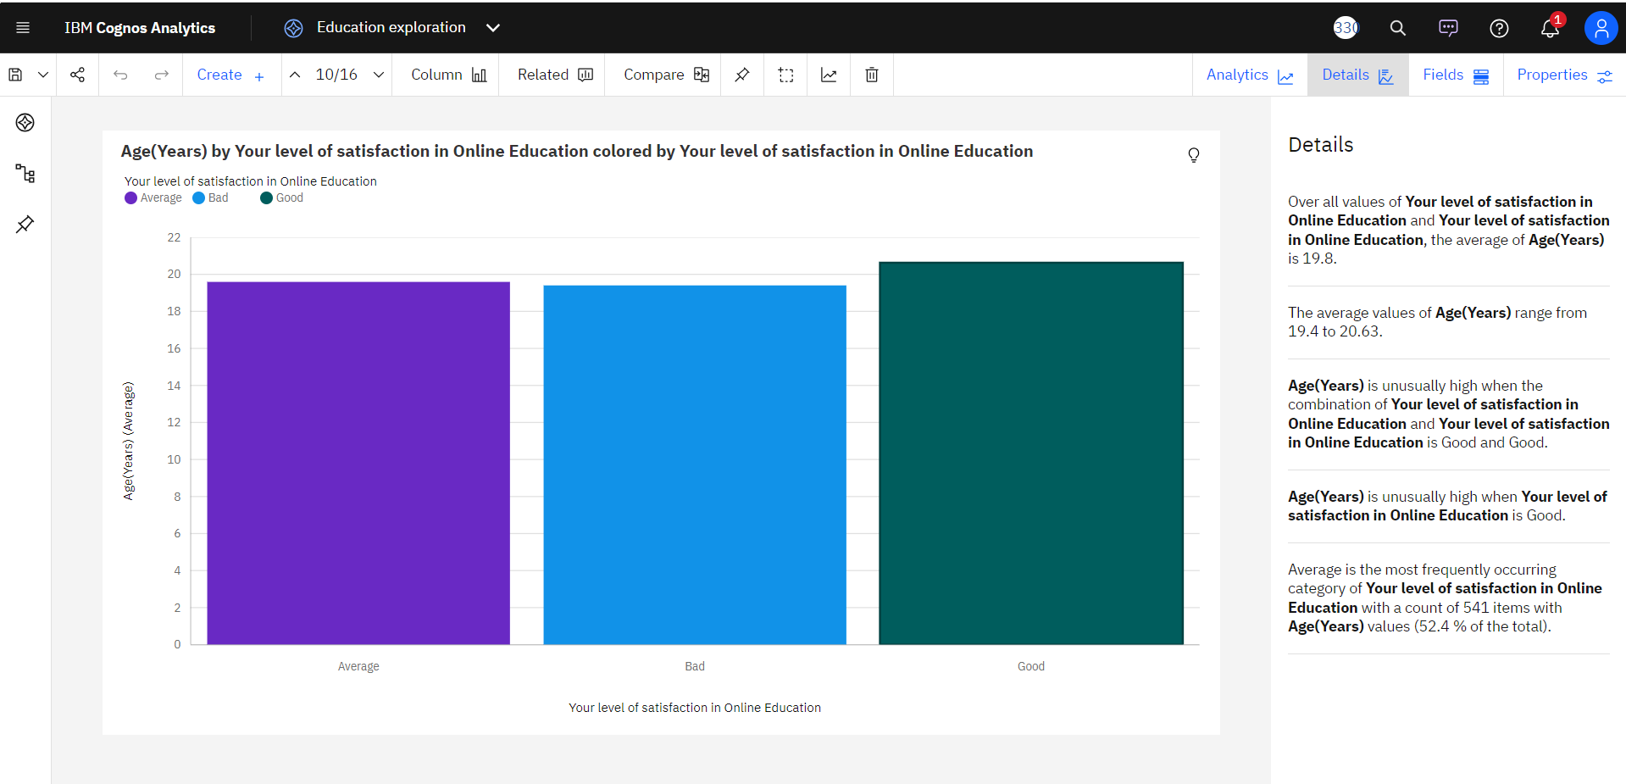

1. **Performance in online by Level of Education colored by Level of Education:**

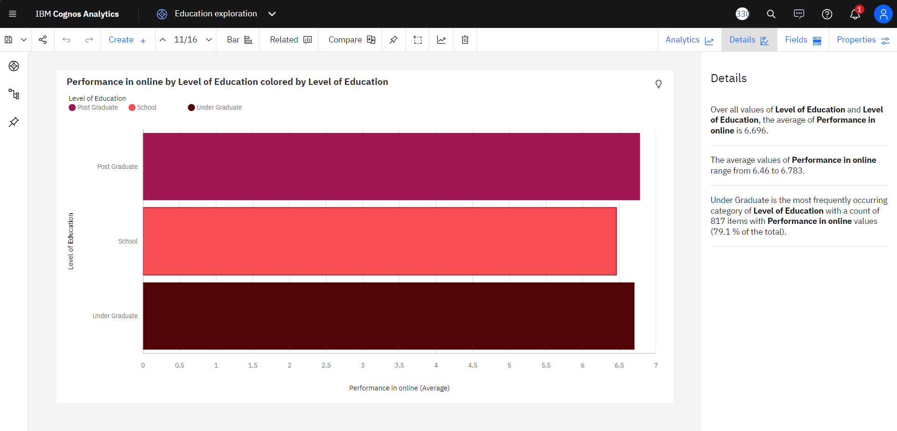

1. **Economic status, Home Location and Performance in online:**

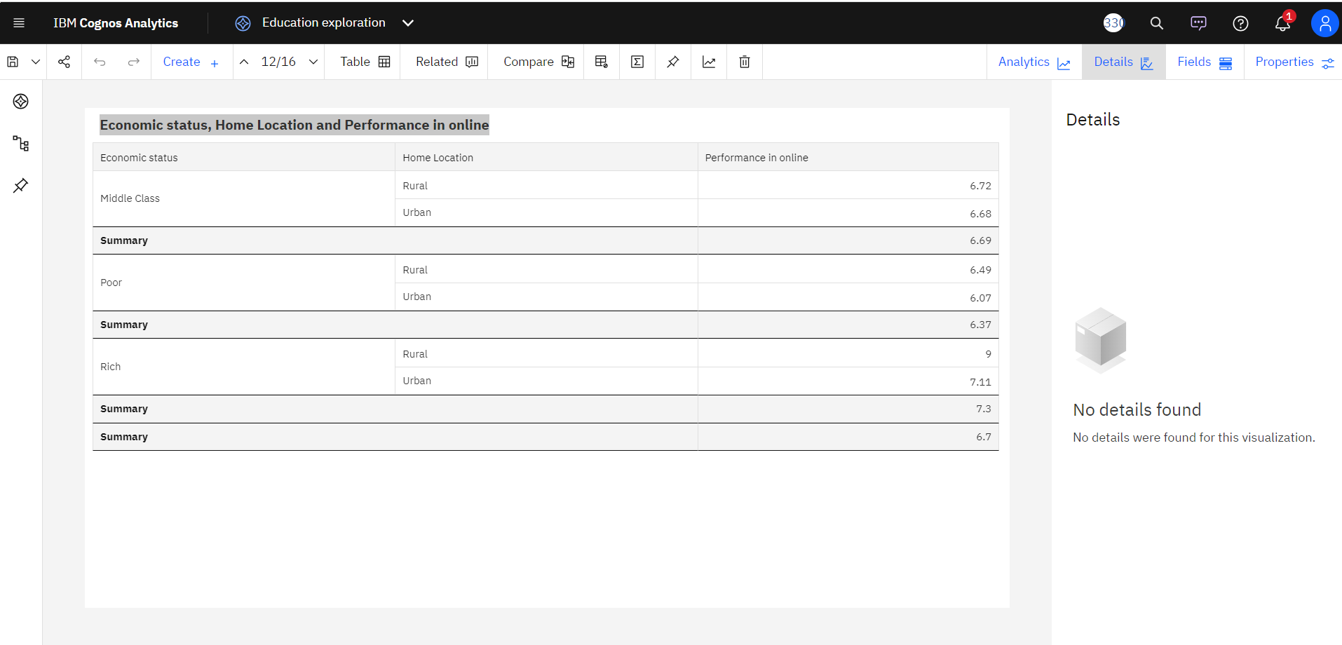

1. **Performance in online by Level of Education:**

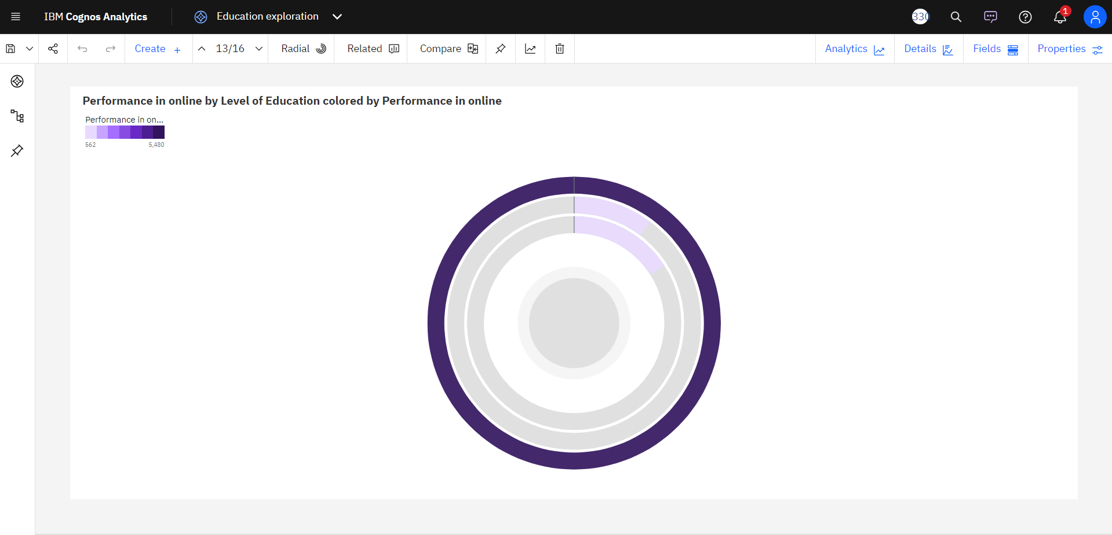

1. **Study time (Hours) by Performance in online:**

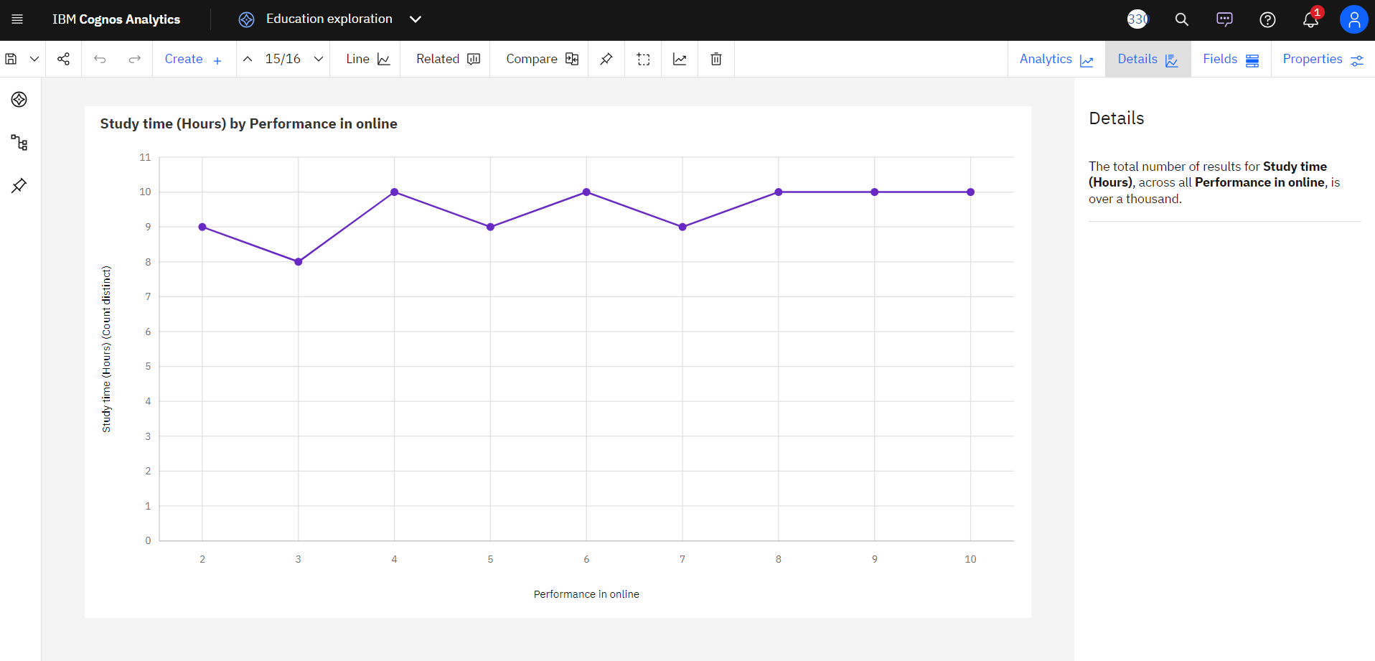

1. **Sleep time (Hours) by Performance in online:**

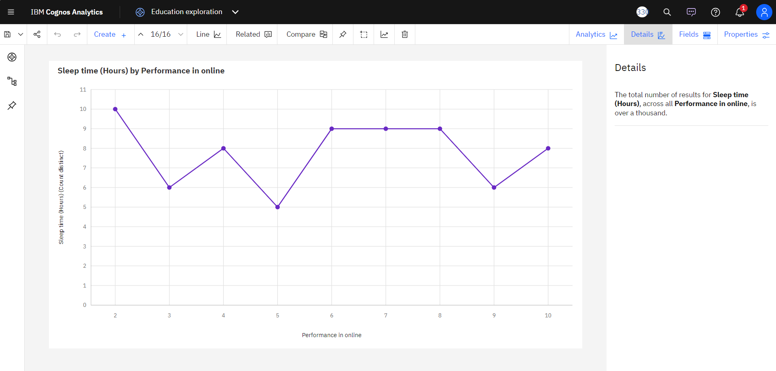

**Online Education Reviews - Dashboard:**

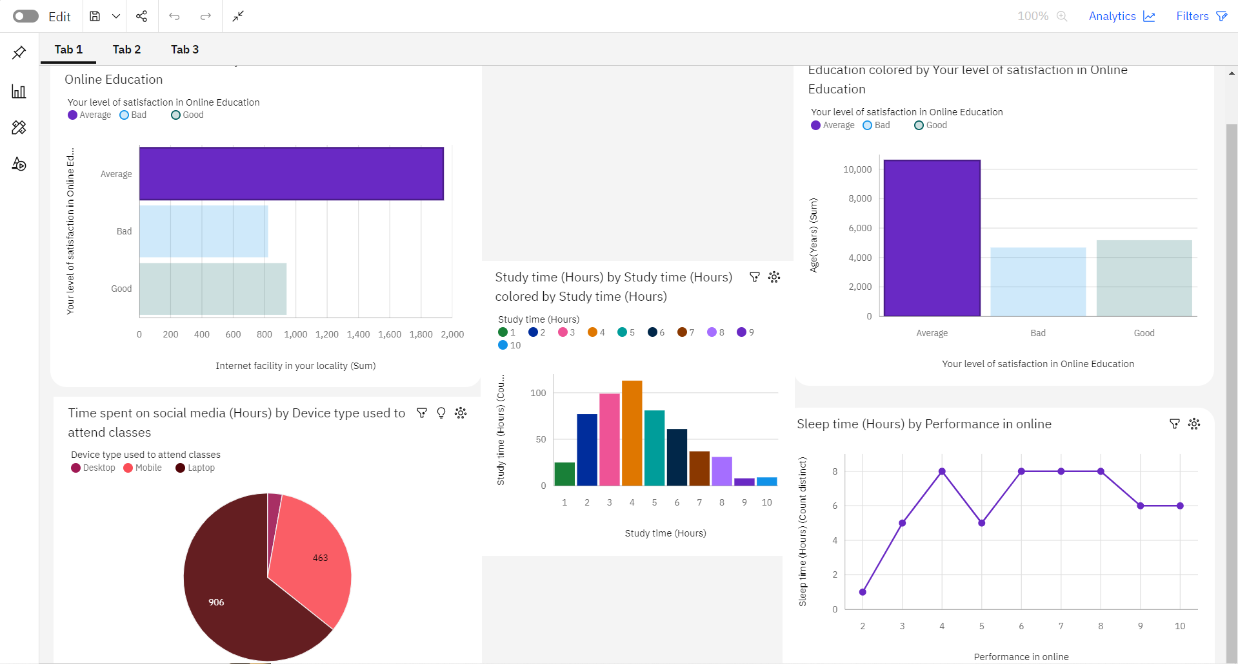

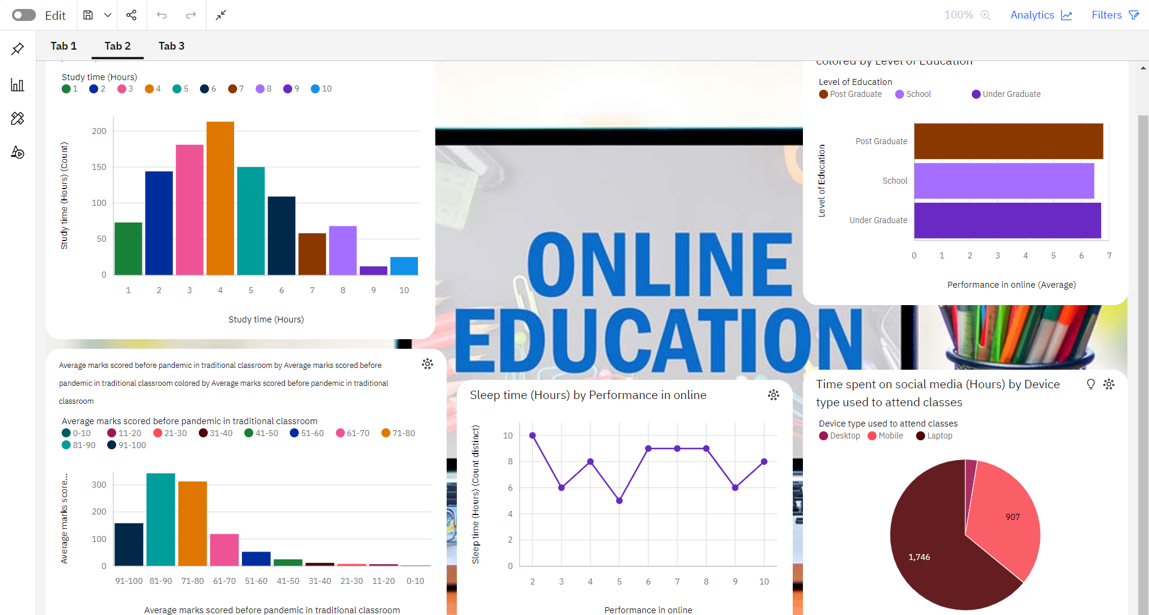

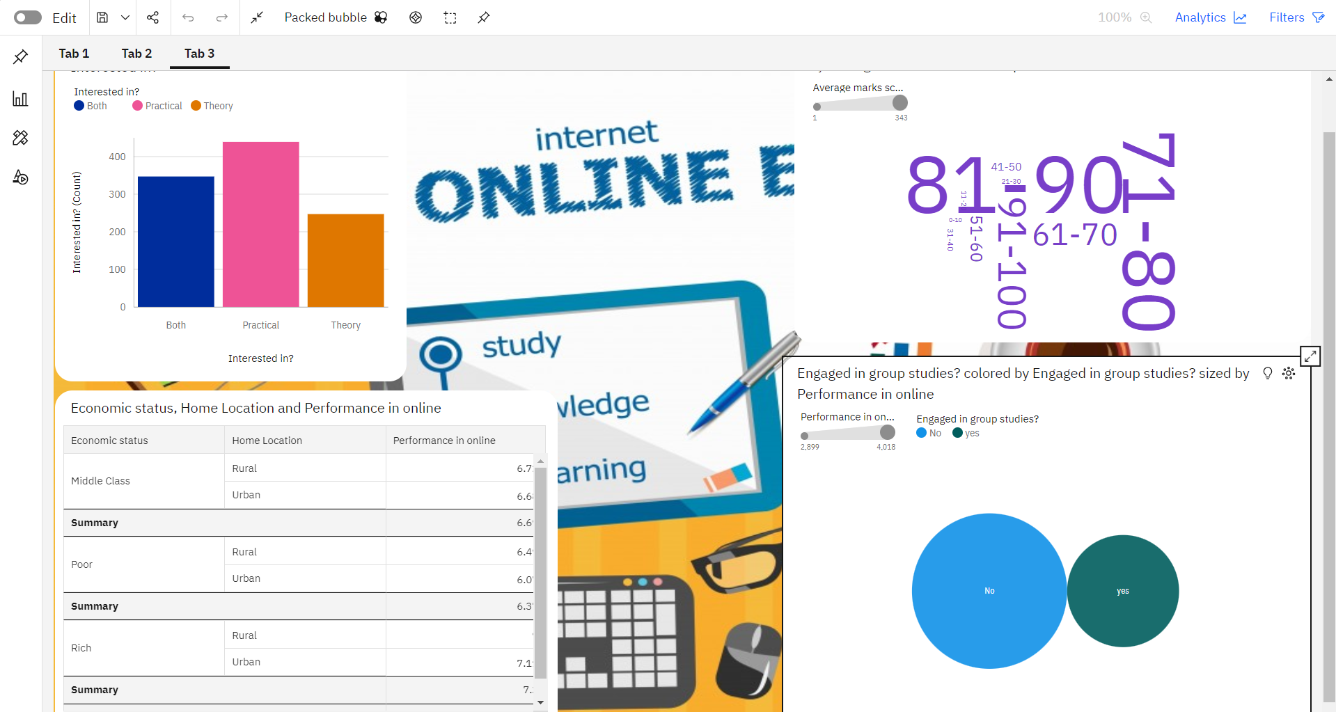

**Online Education Reviews - Story:**

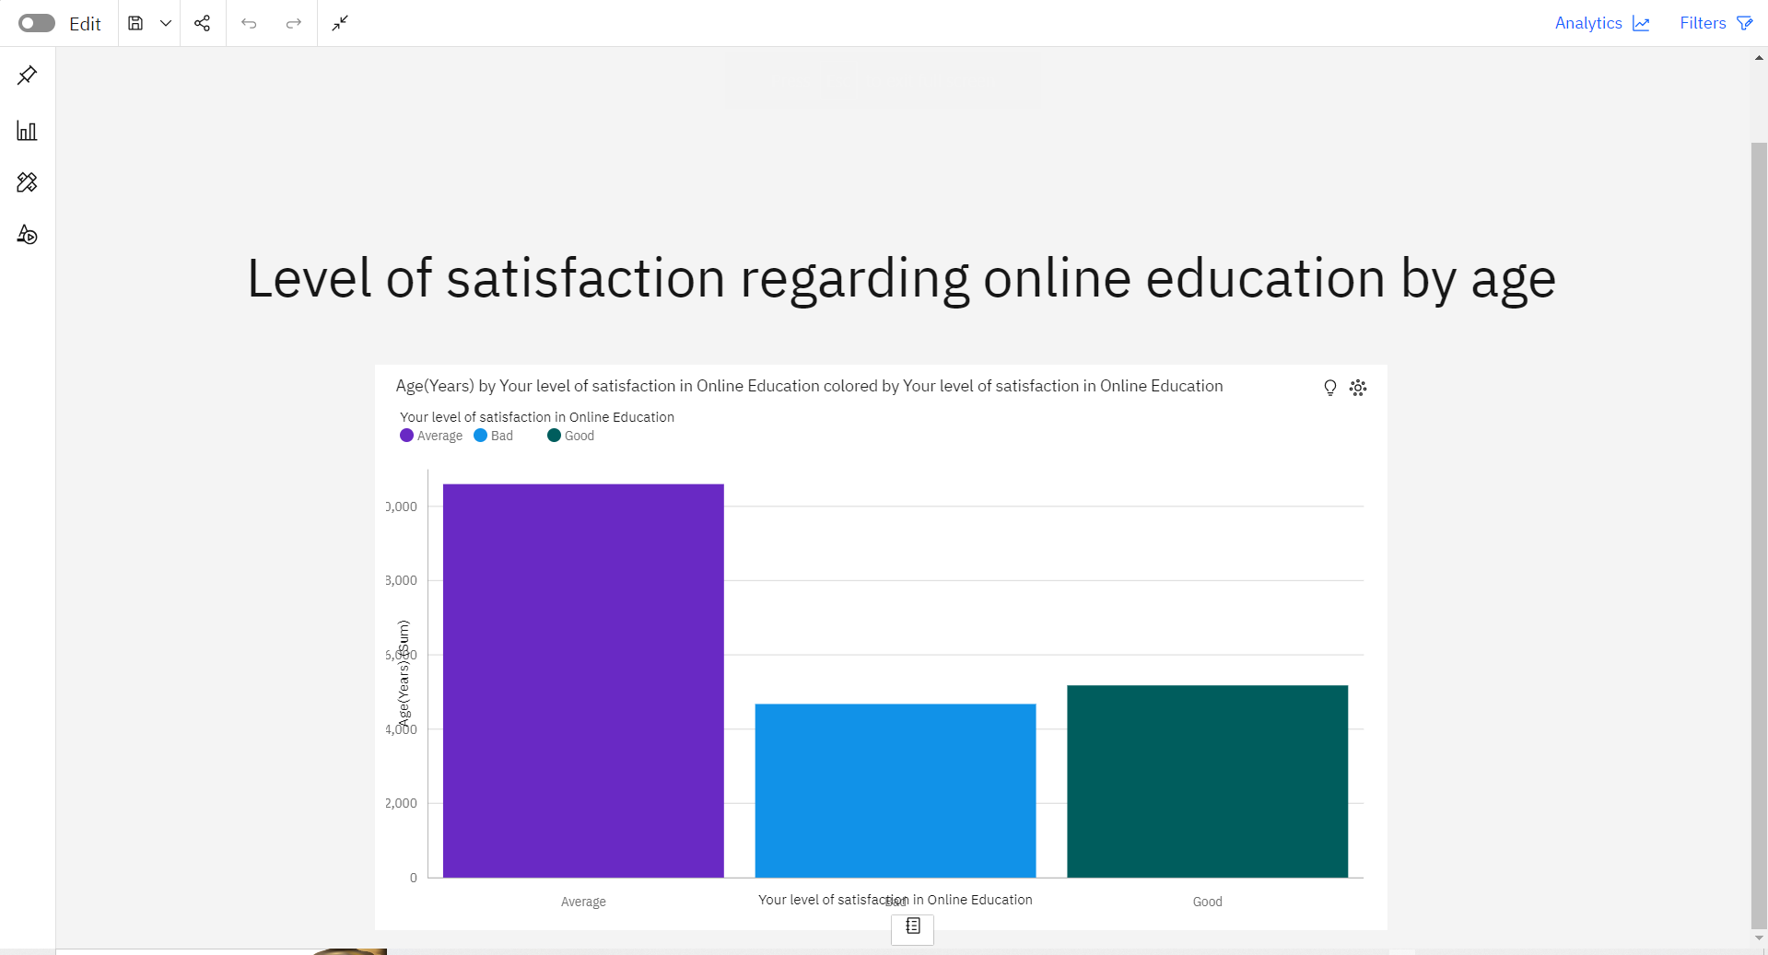

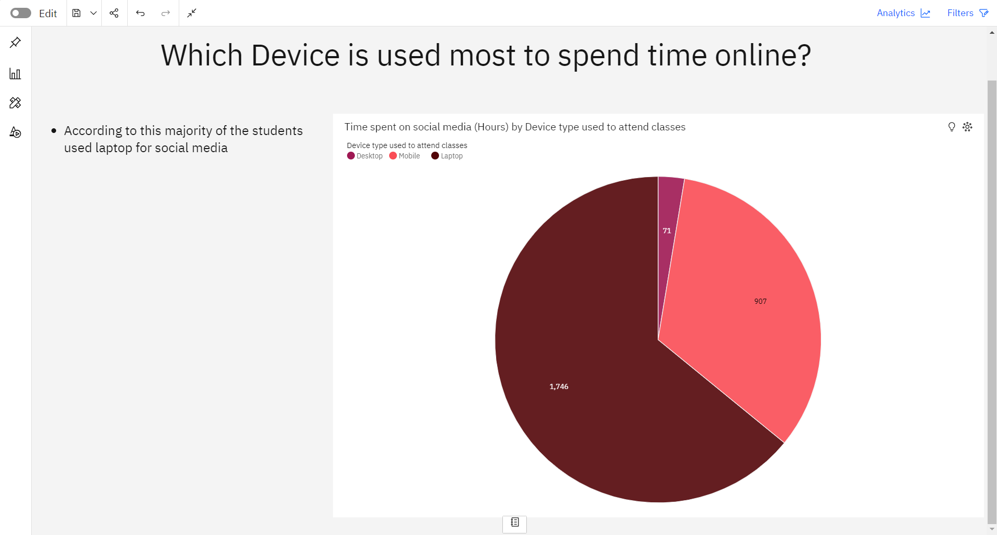

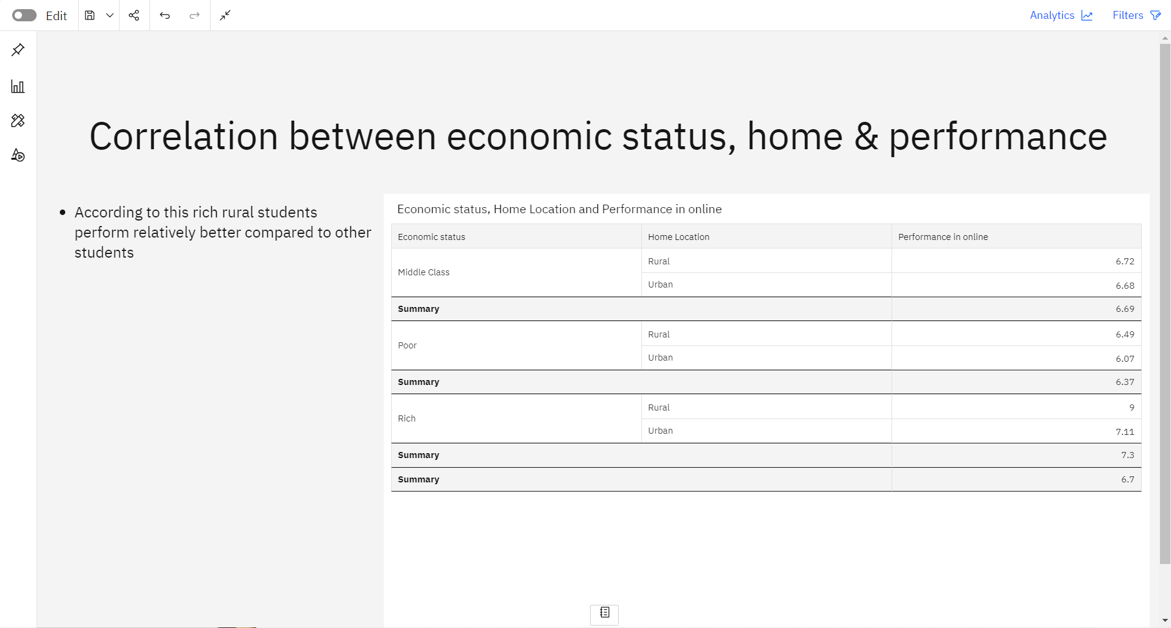

**Online Education Reviews - Report:**

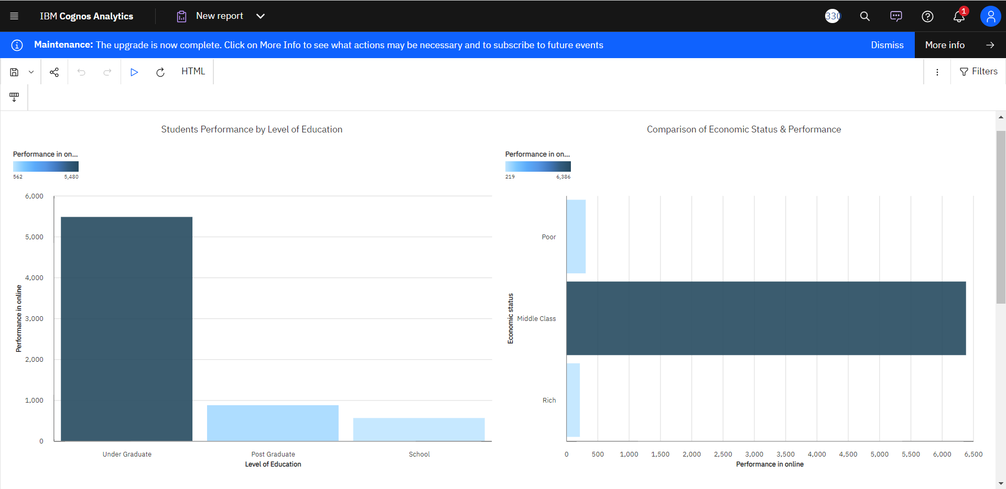

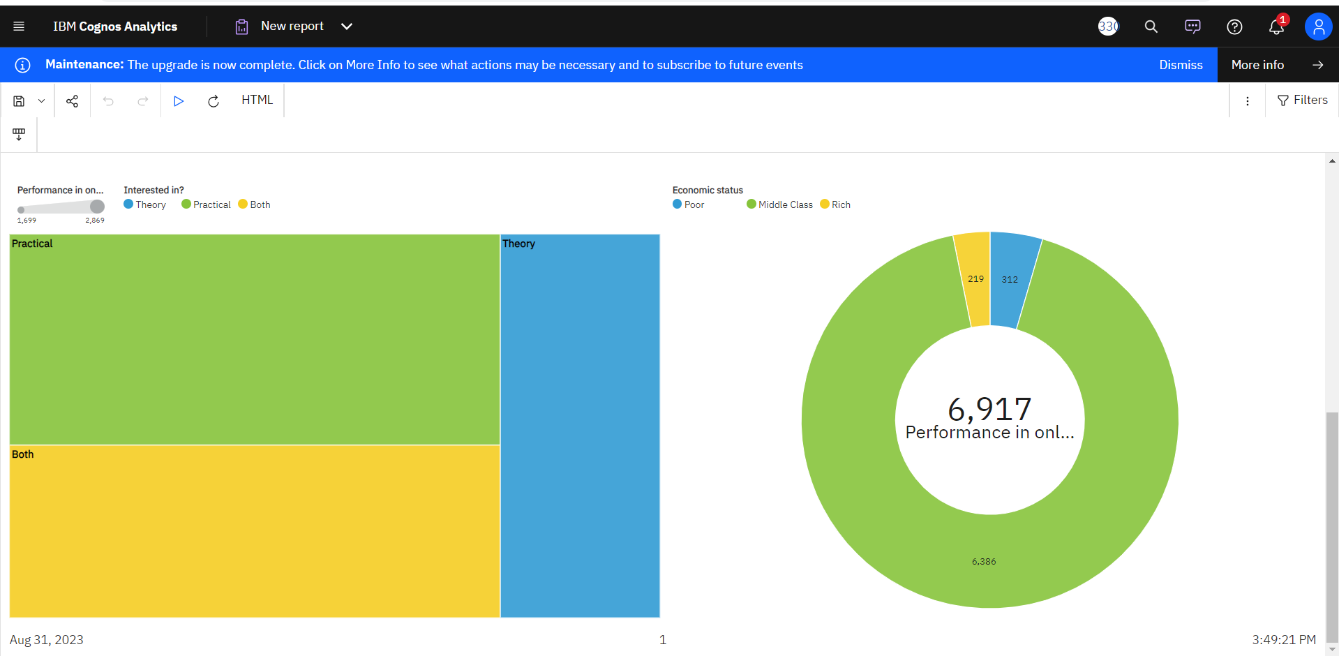

**Online Education Review – Web Integration:**

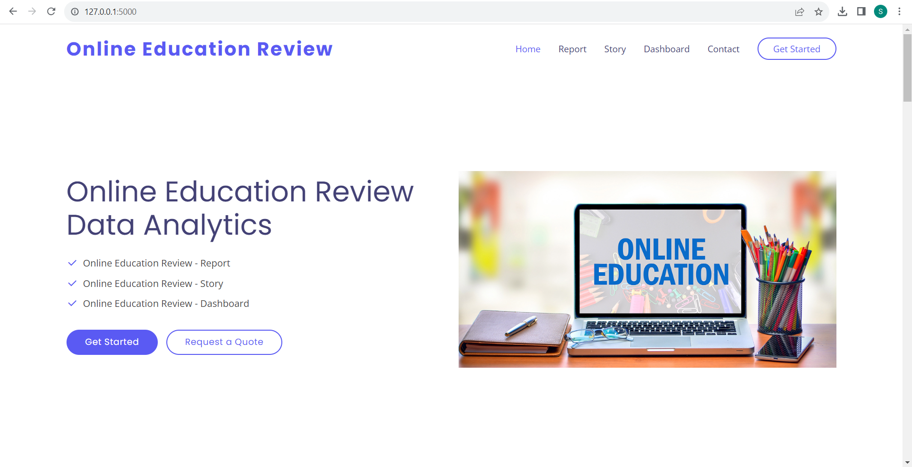

**Embedding Report to Web app:**

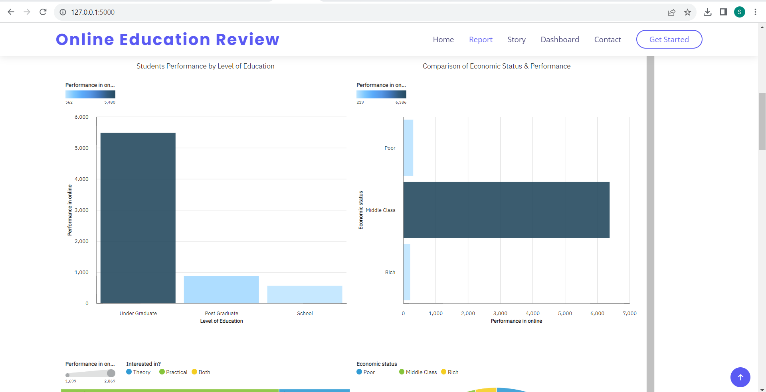

**Embedding Story to Web app:**

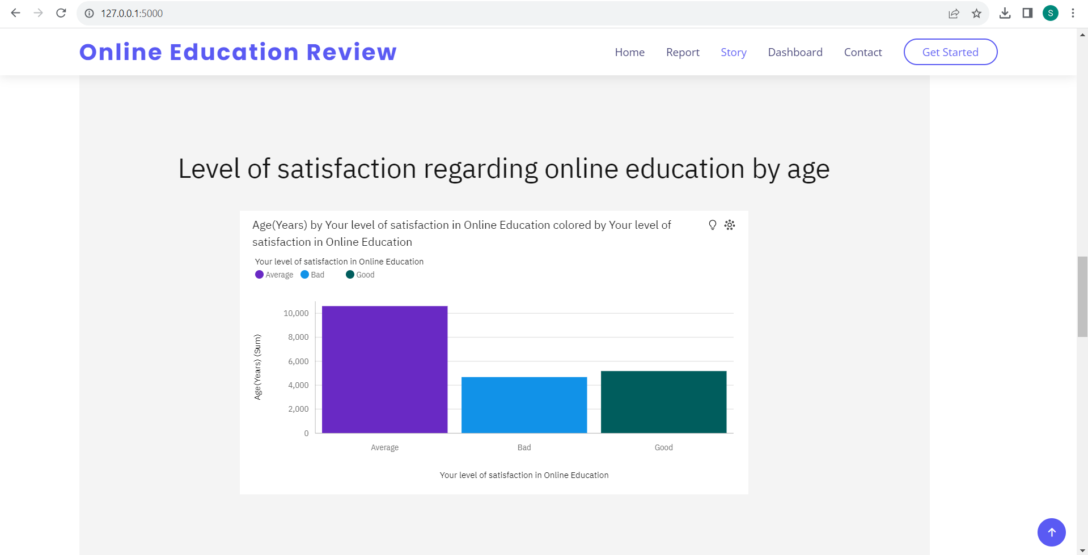

**Embedding Dashboard to Web app:**

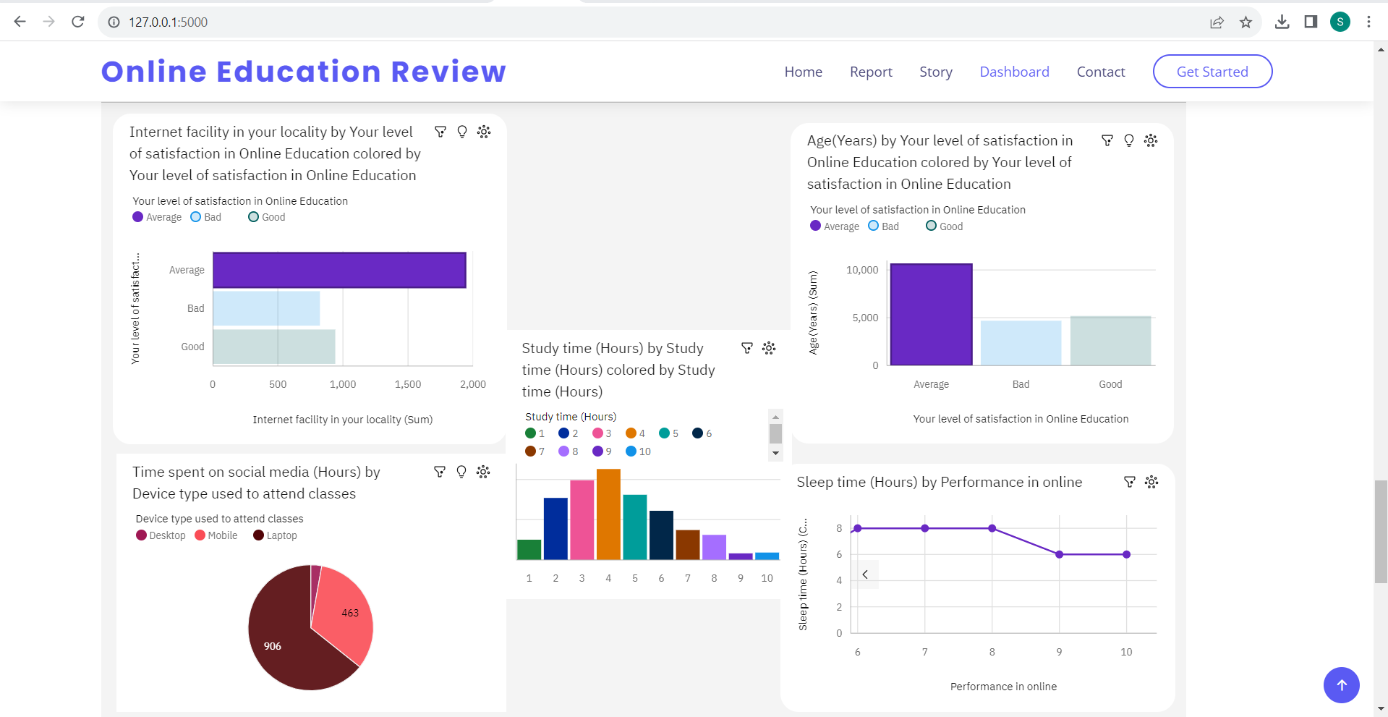

**7. ADVANTAGES & DISADVANTAGES**

**Advantages:**

* It is used to identify, optimize, and forecast online education platforms.
* Reviews data will help a company to take a future decision in terms of choosing virtual platform, marketing activities, schemes or offers to be rolled and changes in online learning processes if applicable.
* An efficient education review model that generates higher revenue for the business.
* Better prediction, Profit function performance.
* Helps to review their strategies and performance in order to make improvements.

**Disadvantages:**

* Reviews pattern can be changed
* Insufficient data may lead to wrong path.
* Data may have been collected for historical reasons may not be suitable to answer the questions that we ask today.
* Business users do not see results immediately

**8. APPLICATIONS**

This analytics model can be applied in any domain like product sales review, online shopping reviews, social media reviews etc. to gain insights and to take decisions in future and to predict the profit/revenue of the product/service to the customers.

**9. CONCLUSION**

Analyzing education methodologies reviews helps education system in understanding their most profitable products and the ones that are not moving, most profitable customers, and potential sales opportunities thereby providing virtual learning platforms which match customer needs and meets their satisfaction. An efficient e-learning tool/framework that generates higher benefit for the students. It helps in the perception of student’s future about particular product and perception of learning tool/mentors in different locations and times.

**10. FUTURE SCOPE**

Use the technology to collect and use sales data to derive actionable insights. It is used to identify, optimize, and forecast customer reviews. An efficient e-learning tool/framework model that generates higher benefit for the students.

**11. BIBLIOGRAPHY**

1. Big Data Analytics and Deep Learning Based Sentiment Analysis System for Sales Prediction - Khatiwada, Aamod and Kadariya, Pradeep and Agrahari, Sandip and Dhakal, Rabin.
2. COVID-19 pandemic in the new era of big data analytics: Methodological innovations and future research directions - Sheng, Jie and Amankwah-Amoah, Joseph and Khan, Zaheer and Wang, Xiaojun
3. Sales Forecasting Based on CatBoost - Jingyi Ding, Ziqing Chen.
4. 2020 2nd International Conference on Broadband Communications, Wireless Sensors and Powering (BCWSP)-Wisesa, Oryza and Adriansyah, Andi and Khalaf, Osamah Ibrahim.
5. Developing and Implementing Big Data Analytics in Marketing - Dina Darwish
6. Social media big data analytics for demand forecasting: development and case implementation of an innovative framework-Iftikhar, Rehan and Khan, Mohammad Saud

**APPENDIX:**

**Source Code:**

**Index.html:**

<!DOCTYPE html>

<html lang="en">

<head>

  <meta charset="utf-8">

  <meta content="width=device-width, initial-scale=1.0" name="viewport">

  <title>Online Education Review</title>

  <meta content="" name="description">

  <meta content="" name="keywords">

  <!-- Favicons -->

  <link href="static/assets/img/favicon.png" rel="icon">

  <link href="static/assets/img/apple-touch-icon.png" rel="apple-touch-icon">

  <!-- Google Fonts -->

  <link href="https://fonts.googleapis.com/css?family=Open+Sans:300,300i,400,400i,600,600i,700,700i|Raleway:300,300i,400,400i,500,500i,600,600i,700,700i|Poppins:300,300i,400,400i,500,500i,600,600i,700,700i" rel="stylesheet">

  <!-- Vendor CSS Files -->

  <link href="static/assets/vendor/bootstrap/css/bootstrap.min.css" rel="stylesheet">

  <link href="static/assets/vendor/bootstrap-icons/bootstrap-icons.css" rel="stylesheet">

  <link href="static/assets/vendor/boxicons/css/boxicons.min.css" rel="stylesheet">

  <link href="static/assets/vendor/glightbox/css/glightbox.min.css" rel="stylesheet">

  <link href="static/assets/vendor/remixicon/remixicon.css" rel="stylesheet">

  <link href="static/assets/vendor/swiper/swiper-bundle.min.css" rel="stylesheet">

  <!-- Template Main CSS File -->

  <link href="static/assets/css/style.css" rel="stylesheet">

  <!-- =======================================================

  * Template Name: Resi

  * Updated: May 30 2023 with Bootstrap v5.3.0

  * Template URL: https://bootstrapmade.com/resi-free-bootstrap-html-template/

  * Author: BootstrapMade.com

  * License: https://bootstrapmade.com/license/

  ======================================================== -->

</head>

<body>

  <!-- ======= Header ======= -->

  <header id="header" class="fixed-top ">

    <div class="container d-flex align-items-center justify-content-between">

      <h1 class="logo"><a href="index.html">Online Education Review</a></h1>

      <!-- Uncomment below if you prefer to use an image logo -->

      <!-- <a href="index.html" class="logo"><img src="assets/img/logo.png" alt="" class="img-fluid"></a>-->

      <nav id="navbar" class="navbar">

        <ul>

          <li><a class="nav-link scrollto active" href="#hero">Home</a></li>

          <li><a class="nav-link scrollto" href="#about">Report</a></li>

          <li><a class="nav-link scrollto" href="#services">Story</a></li>

          <li><a class="nav-link scrollto " href="#portfolio">Dashboard</a></li>

          <li><a class="nav-link scrollto" href="#contact">Contact</a></li>

          <li><a class="getstarted scrollto" href="#about">Get Started</a></li>

        </ul>

        <i class="bi bi-list mobile-nav-toggle"></i>

      </nav><!-- .navbar -->

    </div>

  </header><!-- End Header -->

  <!-- ======= Hero Section ======= -->

  <section id="hero" class="d-flex align-items-center">

    <div class="container">

      <div class="row">

        <div class="col-lg-6 pt-2 pt-lg-0 order-2 order-lg-1 d-flex flex-column justify-content-center">

          <h1>Online Education Review Data Analytics</h1>

          <ul>

            <li><i class="ri-check-line"></i> Online Education Review - Report</li>

            <li><i class="ri-check-line"></i> Online Education Review - Story</li>

            <li><i class="ri-check-line"></i> Online Education Review - Dashboard</li>

          </ul>

          <div class="mt-3">

            <a href="#about" class="btn-get-started scrollto">Get Started</a>

            <a href="" class="btn-get-quote">Request a Quote</a>

          </div>

        </div>

        <div class="col-lg-6 order-1 order-lg-2 hero-img">

          <img src="static/assets/img/online-education.jpg" class="img-fluid" alt="">

        </div>

      </div>

    </div>

  </section><!-- End Hero -->

  <main id="main">

    <!-- ======= About Section ======= -->

    <section id="about" class="about">

      <div class="container">

          <iframe src="https://us1.ca.analytics.ibm.com/bi/?pathRef=.my_folders%2FOnline%2BEducation%2Breport&amp;closeWindowOnLastView=true&amp;ui_appbar=false&amp;ui_navbar=false&amp;shareMode=embedded&amp;action=run&amp;format=HTML&amp;prompt=false" width="1200" height="1000" frameborder="0" gesture="media" allow="encrypted-media" allowfullscreen=""></iframe>

        </div>

      </div>

    </section><!-- End About Section -->

    <!-- ======= services Section ======= -->

    <section id="services" class="services">

      <div class="container">

        <iframe src="https://us1.ca.analytics.ibm.com/bi/?perspective=story&amp;pathRef=.my_folders%2FOnlineEducationStory&amp;closeWindowOnLastView=true&amp;ui_appbar=false&amp;ui_navbar=false&amp;shareMode=embedded&amp;action=view&amp;sceneId=model0000018a357da81f_00000001&amp;sceneTime=0" width="1200" height="1000" frameborder="0" gesture="media" allow="encrypted-media" allowfullscreen=""></iframe>

      </div>

    </section><!-- End services Section -->

    <!-- ======= Portfolio Section ======= -->

    <section id="portfolio" class="portfolio">

      <div class="container">

        <iframe src="https://us1.ca.analytics.ibm.com/bi/?perspective=dashboard&amp;pathRef=.my_folders%2Fonline%2Beducation%2Bdashboard&amp;closeWindowOnLastView=true&amp;ui_appbar=false&amp;ui_navbar=false&amp;shareMode=embedded&amp;action=view&amp;mode=dashboard&amp;subView=model00000189dde8d7d1_00000000" width="1200" height="1000" frameborder="0" gesture="media" allow="encrypted-media" allowfullscreen=""></iframe>

      </div>

    </section><!-- End Portfolio Section -->

    <!-- ======= Team Section ======= -->

    <section id="team" class="team section-bg">

      <div class="container">

      </div>

    </section><!-- End Team Section -->

  </main><!-- End #main -->

  <!-- ======= Footer ======= -->

  <footer id="footer">

    <div class="footer-top">

      <div class="container">

        <div class="row">

          <div class="col-lg-3 col-md-6 footer-contact">

            <h3>Resi.</h3>

            <p>

              A108 Adam Street <br>

              New York, NY 535022<br>

              United States <br><br>

              <strong>Phone:</strong> +1 5589 55488 55<br>

              <strong>Email:</strong> info@example.com<br>

            </p>

          </div>

          <div class="col-lg-2 col-md-6 footer-links">

            <h4>Useful Links</h4>

            <ul>

              <li><i class="bx bx-chevron-right"></i> <a href="#">Home</a></li>

              <li><i class="bx bx-chevron-right"></i> <a href="#">About us</a></li>

              <li><i class="bx bx-chevron-right"></i> <a href="#">Services</a></li>

              <li><i class="bx bx-chevron-right"></i> <a href="#">Terms of service</a></li>

              <li><i class="bx bx-chevron-right"></i> <a href="#">Privacy policy</a></li>

            </ul>

          </div>

          <div class="col-lg-3 col-md-6 footer-links">

            <h4>Our Services</h4>

            <ul>

              <li><i class="bx bx-chevron-right"></i> <a href="#">Web Design</a></li>

              <li><i class="bx bx-chevron-right"></i> <a href="#">Web Development</a></li>

              <li><i class="bx bx-chevron-right"></i> <a href="#">Product Management</a></li>

              <li><i class="bx bx-chevron-right"></i> <a href="#">Marketing</a></li>

              <li><i class="bx bx-chevron-right"></i> <a href="#">Graphic Design</a></li>

            </ul>

          </div>

          <div class="col-lg-4 col-md-6 footer-newsletter">

            <h4>Join Our Newsletter</h4>

            <p>Tamen quem nulla quae legam multos aute sint culpa legam noster magna</p>

            <form action="" method="post">

              <input type="email" name="email"><input type="submit" value="Subscribe">

            </form>

          </div>

        </div>

      </div>

    </div>

    <div class="container d-md-flex py-4">

      <div class="me-md-auto text-center text-md-start">

        <div class="copyright">

          &copy; Copyright <strong><span>Resi</span></strong>. All Rights Reserved

        </div>

        <div class="credits">

          <!-- All the links in the footer should remain intact. -->

          <!-- You can delete the links only if you purchased the pro version. -->

          <!-- Licensing information: https://bootstrapmade.com/license/ -->

          <!-- Purchase the pro version with working PHP/AJAX contact form: https://bootstrapmade.com/resi-free-bootstrap-html-template/ -->

          Designed by <a href="https://bootstrapmade.com/">BootstrapMade</a>

        </div>

      </div>

      <div class="social-links text-center text-md-right pt-3 pt-md-0">

        <a href="#" class="twitter"><i class="bx bxl-twitter"></i></a>

        <a href="#" class="facebook"><i class="bx bxl-facebook"></i></a>

        <a href="#" class="instagram"><i class="bx bxl-instagram"></i></a>

        <a href="#" class="google-plus"><i class="bx bxl-skype"></i></a>

        <a href="#" class="linkedin"><i class="bx bxl-linkedin"></i></a>

      </div>

    </div>

  </footer><!-- End Footer -->

  <a href="#" class="back-to-top d-flex align-items-center justify-content-center"><i class="bi bi-arrow-up-short"></i></a>

  <!-- Vendor JS Files -->

  <script src="static/assets/vendor/purecounter/purecounter_vanilla.js"></script>

  <script src="static/assets/vendor/bootstrap/js/bootstrap.bundle.min.js"></script>

  <script src="static/assets/vendor/glightbox/js/glightbox.min.js"></script>

  <script src="static/assets/vendor/isotope-layout/isotope.pkgd.min.js"></script>

  <script src="static/assets/vendor/swiper/swiper-bundle.min.js"></script>

  <script src="static/assets/vendor/php-email-form/validate.js"></script>

  <!-- Template Main JS File -->

  <script src="static/assets/js/main.js"></script>

</body>

</html>

**app.py**

from flask import Flask, render_template

app = Flask(__name__)

@app.route("/")

def home():

    return render_template(r"index.html")

if __name__ == "__main__":

    app.run(debug=False, port=5000)

**Project Demo Video Link:**

<https://drive.google.com/file/d/1fso4UMi0JNtxpr14ckVGK5rqEVo9GQzM/view?usp=drive_link>

**Project Related Files Drive Link:**

<https://drive.google.com/drive/folders/1HDz-VkMa9pUM6aBuhryMjYWB7zhQRybm?usp=sharing>

**Github Demo Link:**

<https://github.com/smartinternz02/SI-GuidedProject-535707-1691408071/tree/main>